VELAMMAL ENGINEERING COLLEGE

(An Autonomous Institution)

CHENNAI–600 066



POSTER PRESENTATION CONTEST FOR VEC STUDENTS
(Save Earth)
Organized By
DEPARTMENT OF
PHYSICS

SUBMITTED TO

ENTREPRENEURSHIP DEVELOPMENT CELL

VELAMMAL ENGINEERING COLLEGE
(An Autonomous Institution)

Department of Physics

- Title of the Event : POSTER PRESENTATION CONTEST FOR VEC STUDENTS (Topic – Save Earth)

- Resource Person : Dr. V. Ramesh kumar, Mrs. G. Hamsavalli, Mr. Moses. V. G. Isaiah, Dr. T. Revathy

3. Date : 27.04.2022 (02.45 PM – 04.00 PM)

- Session Type : Online

- Program Type : Poster Presentation
- Annexure- I : List of Participants

- Annexure- II : Broucher, Registration Form
- Annexure- III : Photographs & Certificate

- Annexure- IV : Participants Feedback

Dr. J. Arumugam  Event Coordinator  Department of Physics | Dr. S. Shahil Kirupavathy  Professor & Head  Department of Physics

ANNEXURE-I

LIST OF PARTICIPANTS

S.No | Email Address | NAME | PHONE NUMBER | COLLEGE NAME | DEPARTMENT
1 | sruthiniladeenan@gmail.com | Sruthinila D | 7305753113 | VELAMMAL ENGINEERING COLLEGE | IT
2 | riyavaldaris4@gmail.com | Riya valdaris | 9498352217 | VELAMMAL ENGINEERING COLLEGE | EIE
3 | riyavaldaris4@gmail.com | Riya valdaris | 9498352217 | VELAMMAL ENGINEERING COLLEGE | EIE
4 | gurukeshav56@gmail.com | Guru keshav.v | 9444852382 | VELAMMAL ENGINEERING COLLEGE | MECH-A
5 | priyavenkat2208@gmail.com | Priya.V | 9150882644 | VELAMMAL ENGINEERING COLLEGE | EIE
6 | mamrithaa2003@gmail.com | M.Amrithaa | 7448754002 | VELAMMAL ENGINEERING COLLEGE | EEE
7 | meganath1025@gmail.com | M. MEGANATHAN | 7305307785 | VELAMMAL ENGINEERING COLLEGE | MECH-B
8 | ukeshrajv@gmail.com | Ukeshraj V | 9600837251 | VELAMMAL ENGINEERING COLLEGE | ECE-B
9 | heamavarshini2004@gamil.com | HEAMAVARSHINI K | 8248253223 | VELAMMAL ENGINEERING COLLEGE | EIE
10 | heamavarshini2004@gmail.com | Heamavarshini.k | 8248253223 | VELAMMAL ENGINEERING COLLEGE | EIE
11 | anbu9112003@gmail.com | Anbu.S | 7338783462 | VELAMMAL ENGINEERING COLLEGE | MECH-B
12 | saravanaramaswamy2003@gmail.com | Saravanakumar. R | 8838416187 | VELAMMAL ENGINEERING COLLEGE | ECE-A
13 | thrishak2@gmail.com | Vedavalli | 7845987224 | VELAMMAL ENGINEERING COLLEGE | IT
14 | prithi.palani58@gmail.com | PRITHI PRASANNA. P | 7904185295 | VELAMMAL ENGINEERING COLLEGE | AI&DS
15 | jasminerennita15403@gmail.com | Jasmine Rennita V | 7904523860 | VELAMMAL ENGINEERING COLLEGE | AI&DS
16 | trishababu.29@gmail.com | Trisha B | 8939321031 | VELAMMAL ENGINEERING COLLEGE | AI&DS
17 | jasminerennita15403@gmail.com | Jasmine Rennita V | 7904523860 | VELAMMAL ENGINEERING COLLEGE | AI&DS
18 | tanishwari@gmail.com | Tanisha Mukundan | 9962723842 | VELAMMAL ENGINEERING COLLEGE | AI&DS
19 | parnika3105@gmail.com | PARNIKA R | 8925281323 | VELAMMAL ENGINEERING COLLEGE | AI&DS
20 | parnika3105@gmail.com | Parnika | 8925281323 | VELAMMAL ENGINEERING COLLEGE | AI&DS
21 | swathisree148@gmail.com | Swathi sree M | 9677279297 | VELAMMAL ENGINEERING COLLEGE | IT
22 | lokeshsharma46960@gmail.com | Sarulatha Akshaya | 7010779009 | VELAMMAL ENGINEERING COLLEGE | IT
23 | abinesh2004abi@gmail.com | R.Abinesh | 7200300165 | VELAMMAL ENGINEERING COLLEGE | EEE
24 | mr.yogesh.ceo@gamil.com | Yogesh kumar | 8925402112 | VELAMMAL ENGINEERING COLLEGE | MECH-B

ANNEXURE –II

(BROUCHER, REGISTRATION FORM)
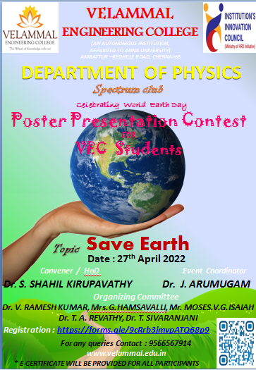

Registration form link : https://forms.gle/9cRrb3jmvpATQ68p9

ANNEXURE –III
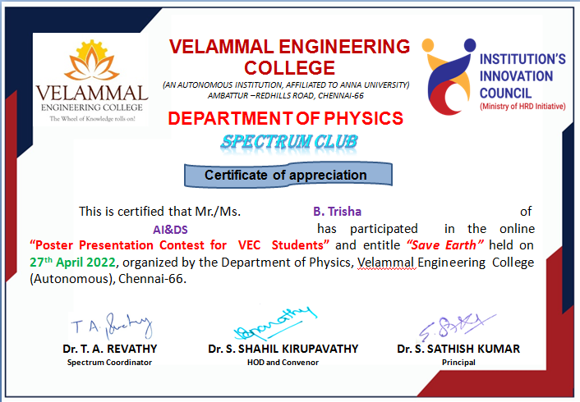
Photographs & Certificate

ANNEXURE –IV
Participants Feedback

Sl.No | NAME | Feedback
1 | Ramesh kumar | Excellent | Very Informative posters
2 | MOSES V.G.ISAIAH | Excellent | Informative and Innovative posters
3 | G. Hamsavalli | Excellent | Wonderful poster presentation about save earth
4 | Sruthinila D | Very Good | I have learnt many new things apart from my core subjects
5 | Riya valdaris | Excellent | About science and innovations and how science plays a pivotal role in technology
6 | Riya valdaris | Very Good | Good, motivational and learned more informations
7 | Guru keshav.v | Excellent | In research purpose it is useful and valuable to gain some Knowledge
8 | Priya.V | Excellent | Wonderful
9 | M.Amrithaa | Excellent | To know about science and used Nano particles save in nature
10 | M. MEGANATHAN | Very Good | The things which he interacted about save nature
11 | Ukeshraj V | Very Good | Useful & very excellent posters
12 | HEAMAVARSHINI K | Excellent | The neat and detailed explanation of the concepts were very useful.
13 | Heamavarshini.k | Excellent | I have gained different ideas
14 | Anbu.S | Excellent | It have interactive so it's easy to understand much in save earth
15 | Saravanakumar. R | Very Good | It was very informative and useful for us to learn new things and enhance our knowledge
16 | Vedavalli | Excellent | I loved all the posters for different ideas
17 | PRITHI PRASANNA. P | Very Good | Helps to know more about science in nation
18 | Jasmine Rennita V | Excellent | It was one of the most informative and valuable
19 | Trisha B | Excellent | Valuable
20 | Jasmine Rennita V | Excellent | I understood the value of science
21 | Tanisha Mukundan | Excellent | Useful & very excellent posters
22 | PARNIKA R | Excellent | Its very useful for as...
23 | Parnika | Excellent | I know about the evolution of science.
24 | Swathi sree M | Excellent | I know about the evolution of science.
25 | Sarulatha Akshaya | Excellent | Valuable
26 | R.Abinesh | Excellent | I loved all the posters for different ideas
27 | Yogesh kumar | Very Good | Clear explanation with appropriate images

